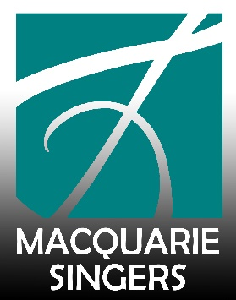
PRINCIPAL CONDUCTOR SEARCH ANNOUNCEMENT
Macquarie Singers Inc. (MUS) is seeking a dynamic and talented, experienced and accomplished Principal Conductor following our current Principal Conductor, Dr Sarah Penicka-Smith’s decision to step down at the end of 2022, having filled the position since 2013.
The ideal candidate will possess the ability to teach music to a non-auditioned SATB choir, conduct the choir in diverse repertoire, show prior experience in producing performances of a high standard and the ability to work and communicate with a committee. The candidate will also be able to demonstrate a long-term vision for the choir, leadership skills and a strong commitment to working with a community choir. Macquarie Singers' Principal Conductor is paid per call for rehearsals, concerts and workshops at a very reasonable rate under contract.
ABOUT MACQUARIE SINGERS
Macquarie Singers, affectionately known as MUS, is an incorporated community choir with registered charity status. We are one of Sydney’s longest continuing choirs, established in 1967 for the staff of Macquarie University in the year it first opened to students.
We perform a diverse repertoire, currently with a strong classical focus. Our membership is open to adults of all ages, cultural backgrounds and levels of experience with music. Weekly rehearsals are held on Monday nights in North Ryde, on Wallumedegal land. Members of our choir come predominantly from Sydney’s North Shore, Willoughby, Ryde, Hornsby and Parramatta areas but many are willing to travel from even further away.
The choir performs two major concerts per year with instrumental ensemble accompaniment as well as singing at smaller community events for residents of Macquarie Hospital and aged care facilities. We also hold free public singing workshops and a yearly Christmas carol event at the North Ryde RSL Club.

Principal Conductor Core Competencies
- an ability to engage with and elicit the best efforts of choristers from a wide range of experience and skills to reach their best performance level
- the skills to develop programs that are suitable for performance by an amateur community choir and which will interest our audience
- an awareness of current guest soloists and instrumentalists and ability to obtain their services
- a commitment to encouraging community engagement, cultural diversity and inclusion and the growth and sustainability of our community choir
- the ability to liaise with a committee on planning and delivering concert performances and singing workshops

The interview process will take place in August 2022 with members of the Macquarie Singers Committee, followed by an audition at one of our rehearsals in early September.
Please email your resume, references and cover letter to Janet Stacey at president@mus.org.au.
DEADLINE
All applications must be received by 8:00pm, Friday 12 August 2022.
ANY APPLICATIONS RECEIVED AFTER THIS DATE WILL NOT BE CONSIDERED.
Link: https://www.mus.org.au/

